Hyperledger Membership Service Provider (MSP) Implementation with Identity Mixer

Identity Mixer Overview
IBM Identity Mixer is a cryptographic protocol suite for strong privacy-preserving authentication, signatures, and transfer of certified attributes. Its trust model and security guarantees are similar to what is ensured by standard X.509 certificates, but the underlying cryptographic algorithms provide more advanced privacy features, such as unlinkability and minimal attribute disclosure, efficiently.
Briefly, the Identity Mixer protocols work as follows:
Setup. The Certificate Issuing Authority's (CA's) signing key pair is generated and the public key is made publicly available.
Issuance. Like for X.509 certificates, user's attributes are issued in the form of a digital certificate, hereafter called credential. A user stores her credentials in a credential wallet application (a web-based or mobile app).
Presentation. A user signs a message or authenticates with her credentials by deriving a fresh and unlinkable presentation token from her credentials according to an access control policy, hereafter called presentation policy. A presentation policy specifies which attributes (or which predicates about curtain attributes) from which type of credential a user should include in the presentation token. It also specifies the public key(s) of the credential issuing authority(ies), which the verifier trusts to correctly certify users' attributes. If the user consents to disclose the information required by the policy, the presentation token is sent for verification.
Verification. The token is verified whether the token satisfies the presentation policy using the public key(s) of the credential issuing authority(ies).
More details on the concepts and features of the Identity Mixer technology are described in the paper Concepts and Languages for Privacy-Preserving Attribute-Based Authentication.
More information about the Identity Mixer code, demos, and publications is available on the Identity Mixer project home page.

Identity Mixer MSP for Hyperledger Fabric
The membership service that is instantiated with the Identity Mixer protocols works as follows (see the Figure).
Setup. The Certificate Authority (CA) signing key pair is generated and the public key is made available to the blockchain participants.
Enrollment (Issuance). A peer or a client generates a secret key and creates a request for an enrollment certificate (ECert). The (CA) issues an ECert in the form of an Identity Mixer credential. The enrollment certificate also contains the attributes that the member of the chain (or a peer) has. The ECert is stored together with the corresponding credential secret key on the peer side or by the client SDK.
Signing Transactions (Presentation). When a client or a peer needs to sign a transaction, it generates a fresh unlinkable presentation token, which: 1) signs the transaction content, 2) proves a possession of a valid ECert issued by the CA, 3) discloses the attributes that are required by the access control policy for the transaction.
Verifying Transaction Signatures (Verification). The token is verified using the CA's public key.
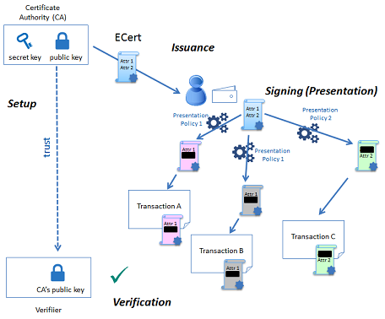

Identity Mixer Security and Privacy Features
We highlight the main Identity Mixer security and privacy features and compare Identity Mixer credentials with standard X.509 certificates.

Strong Authentication and Unforgeability
The certificate/credential concept and the issuance process is very similar in both systems: a set of attributes is digitally signed with an unforgeable signature scheme and there is a secret key to which a certificate is cryptographically bound.
The main difference is in the signature scheme that is used to certify the attributes: the ones underlying the Identity Mixer system allow for efficient so-called zero-knowledge proofs of possession of a signature and the corresponding attributes. Namely, such proofs do not reveal the signature and (selected) attribute values themselves, but only prove that the signature on some attributes is valid and the user is in possession of the corresponding credential secret key.
Such proof, like the X.509 certificates, can be verified with the public key of the authority that originally signed the credential and cannot be forged. Only the user who knows the credential secret key can generate such proofs about her credential and its attributes.

No linkability
When an X.509 certificate is presented, all attributes have to be revealed to verify the certificate signature. This implies that all certificate usages for signing transactions are linkable.
To avoid such linkability, fresh X.509 certificates need to be used every time, which results in complex key management and communication and storage overhead. Furthermore, the CA who issues the single-use transaction certificates (TCerts) can still link all the transactions by the same user since it learns the connection between ECert and TCerts during the TCert issuance and the TCerts are attached to the signed transactions.
Identity Mixer helps to avoid such linkability with respect to both the CA and verifiers, since even the CA is not able to link presentation tokens to the original credential. Neither the CA, no a verifier can tell if two prentation tokens were derived from the same or two different credentials. In an example on the Figure below, although transaction A and transaction B are signed with the same credential, the signatures cannot be link together.
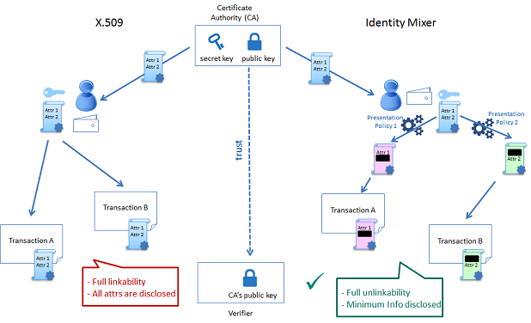

Minimal Attribute Disclosure and Predicates
Besides being able to hide all or only selected attributes during presentation, the Identity Mixer algorithms allow one to prove only predicates about attributes without revealing their values. For example, one can prove that he/she is older than 21 years old by proving that the date of birth attribute lies more than 21 years in the past without revealing the exact date of birth from his/her credential.

Revocation
X.509 certificates can be revoked by adding a unique certificate ID to the black list (so-called certificate revocation list, or CRL) and during verification checking if the certificate is not on the current CRL.
Since revealing unique identifiers for the revocation check via a standard CRL would break the unlinkability, Identity Mixer implements privacy preserving revocation mechanisms that allow a verifier to check if a credential was not revoked (that the credential is not blacklisted) in a zero-knowledge way, i.e., without breaking the unlinkability of unrevoked users.
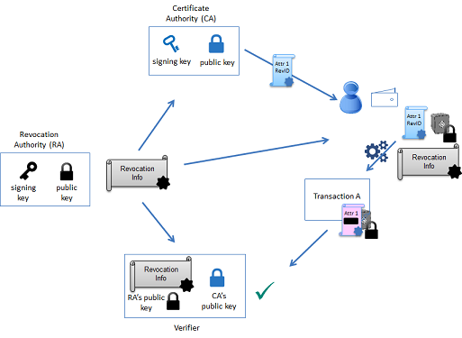

Audit (Inspection)
Audit of the transactions is a very important feature and a requirement for many blockchains. In X.509 systems the CA needs to be involved in the audit since the CA can link all the transactions. Identity Mixer allows only specially assigned parties to break the unlinkability of certain transactions under particular circumstances.
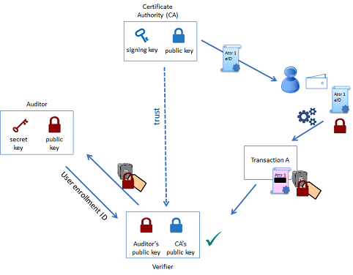

Cryptographic protocols underlying the Identity Mixer system
IBM Identity Mixer technology is built from the blind signature schemes that support multiple messages and
efficient zero-knowledge proofs of possession of a signature. All cryptographic building blocks were published at the top conferences and journals and verified by the scientific community.
This particular Identity Mixer implementation uses a pairing-based signature scheme that was briefly proposed by Camenisch and Lysyanskaya and described in detail by Au et al. Please refer to the latter paper for the algorithm details and security proofs.

Identity Mixer code for Hyperledger
Identity Mixer contribution to the Hyperledger fabric will consist of the following packages:
- a core Identity Mixer crypto package that implements creating issuer keys, issuing credentials, and generating and verifying presentation tokens;
- a CA service (implementation of the fabric-ca endpoints for registration, enrollment, and revocation) for issuing ECert credentials using the Identity Mixer crypto package;
- membership service provider implementation for signing and verifying the transactions using the Identity Mixer crypto package;
- the corresponding contributions to the Client SDK in Java and Node.js.
An overview of the code contribution is presented on the Figure below.

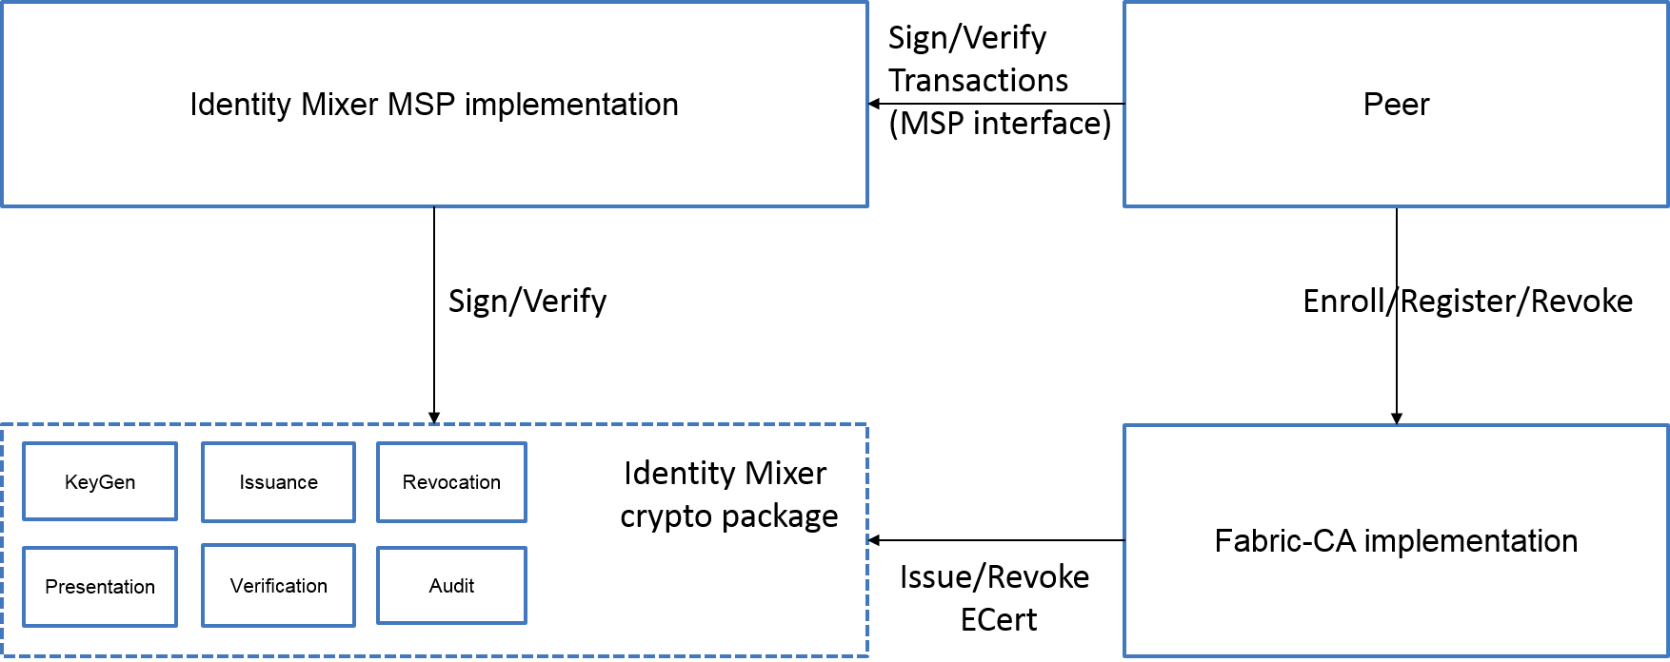

Overview of the current contribution and features
Integration of Identity Mixer into the HL consists of the following contributions:
- (committed) The Identity Mixer crypto package that supports the CA key generation, certificate issuance, presentation token generation and verification. It provides full unlinkability of signatures and selective disclosure of attributes;
- (ready to commit) The Identity Mixer MSP implementation and integration;
- (in progress) The CA integration;
- (in progress) Client-SDK contributions in Java and Node.js;
- (planned) Revocation and auditing features of the crypto package and their integration.

Dependencies
Identity Mixer implementation in GO for the Hyperledger fabric requires only one additional dependency - a fork from the Miracl crypto library - both are licensed under Apache v2.0.

